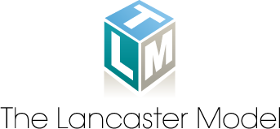

Improving outcomes for children, young people and their families
Coming To Your Childs School Soon

Year 6 pupils will be given the opportunity to complete a questionnaire through the TLM Portal in school.

Your child or young person will have the opportunity to complete a Health Questionnaire on line and ask for help, support and information if needed.

Information will be treated as confidential. Anonymous information will be shared with partner agencies to improve services for children.
Following completion all responses will be reviewed by a qualified Nurse who may then contact you to share your child’s responses.
- Their responses are looked at by the School Nurse .We won’t show anyone else not even your child’s School.
- The questionnaire is completed online in school.
Q. How does my child complete the questionnaire ?
Q. Who sees my child’s answers?

