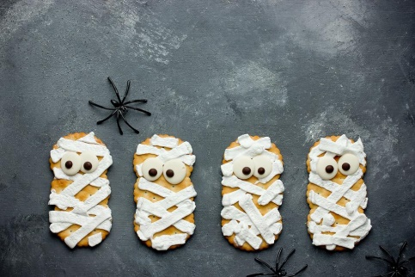
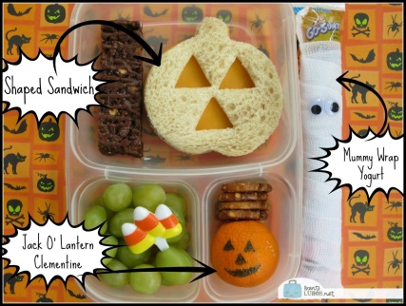
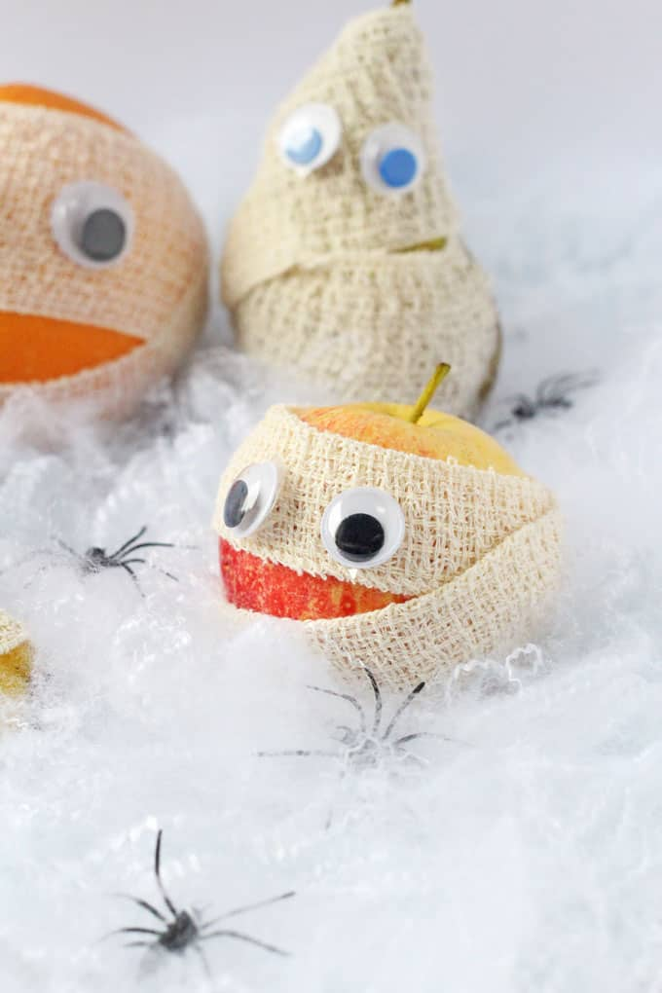
Decorate Biscuits with icing.

Create a spooky pack lunch.
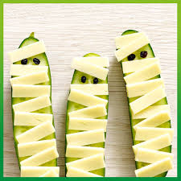
Wrap fruit and drinks up in bandages
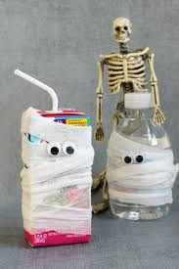
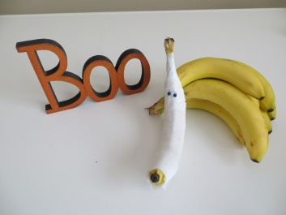
to look like mummies.

Cucumber and cheese

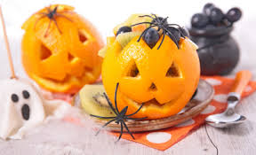
Cut out Mandarin Oranges and fill with tinned or fresh fruit. You may need help from a grown up.
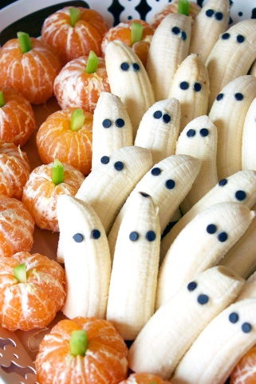

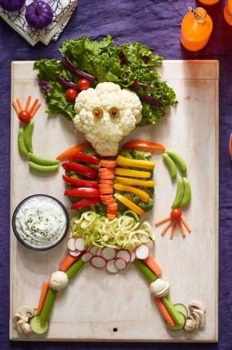

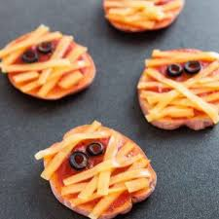
Peel Oranges and bananas

Add strips of Cheese and vegetables to plain pizza’s to make them look Creepy.

Let your imagination run wild

