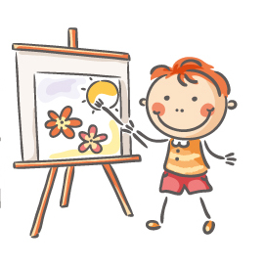
School Readiness

Handy hints on how to get your kids cool for school

- Chat with your child about any worries they may have about starting school and reassure them that this is an exciting and positive time.
- Read books with your child on starting school and encourage questions so they can build up a good picture of how school life will be.
- If possible arrange for your child to attend nursery or pre-school sessions which will help improve their confidence and social interaction with other children.
- Practice potential new morning and bedtime routines to aid a smooth transition of any changes in these.
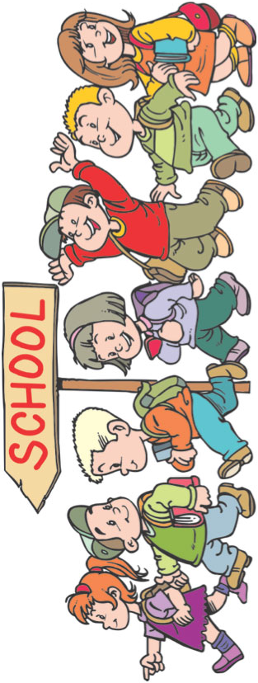
- Involve your child in choosing their uniform and encourage independent dressing as this will help with self-care skills and new routines.
- Practice school runs to help with effective time management and easing of stress for all.
- Encourage your child to get to know potential new classmates and arrange play dates to encourage social interaction and easing of anxiety on their first day.
- Try role play scenarios so that your child gets an idea of what it may be like being in a classroom and expected behaviour to help encourage good behaviour at school.
- Ensure your child is fully independent in toileting skills to avoid potential embarrassment and mishaps.
- Always seek help and advice from your child’s teachers/educational staff if you have any concerns about your child in school.

Common Reactions From Children When Starting School

- Restless or fidgety
- Withdrawn
- Anxious
- Challenging/Aggressive Behaviour
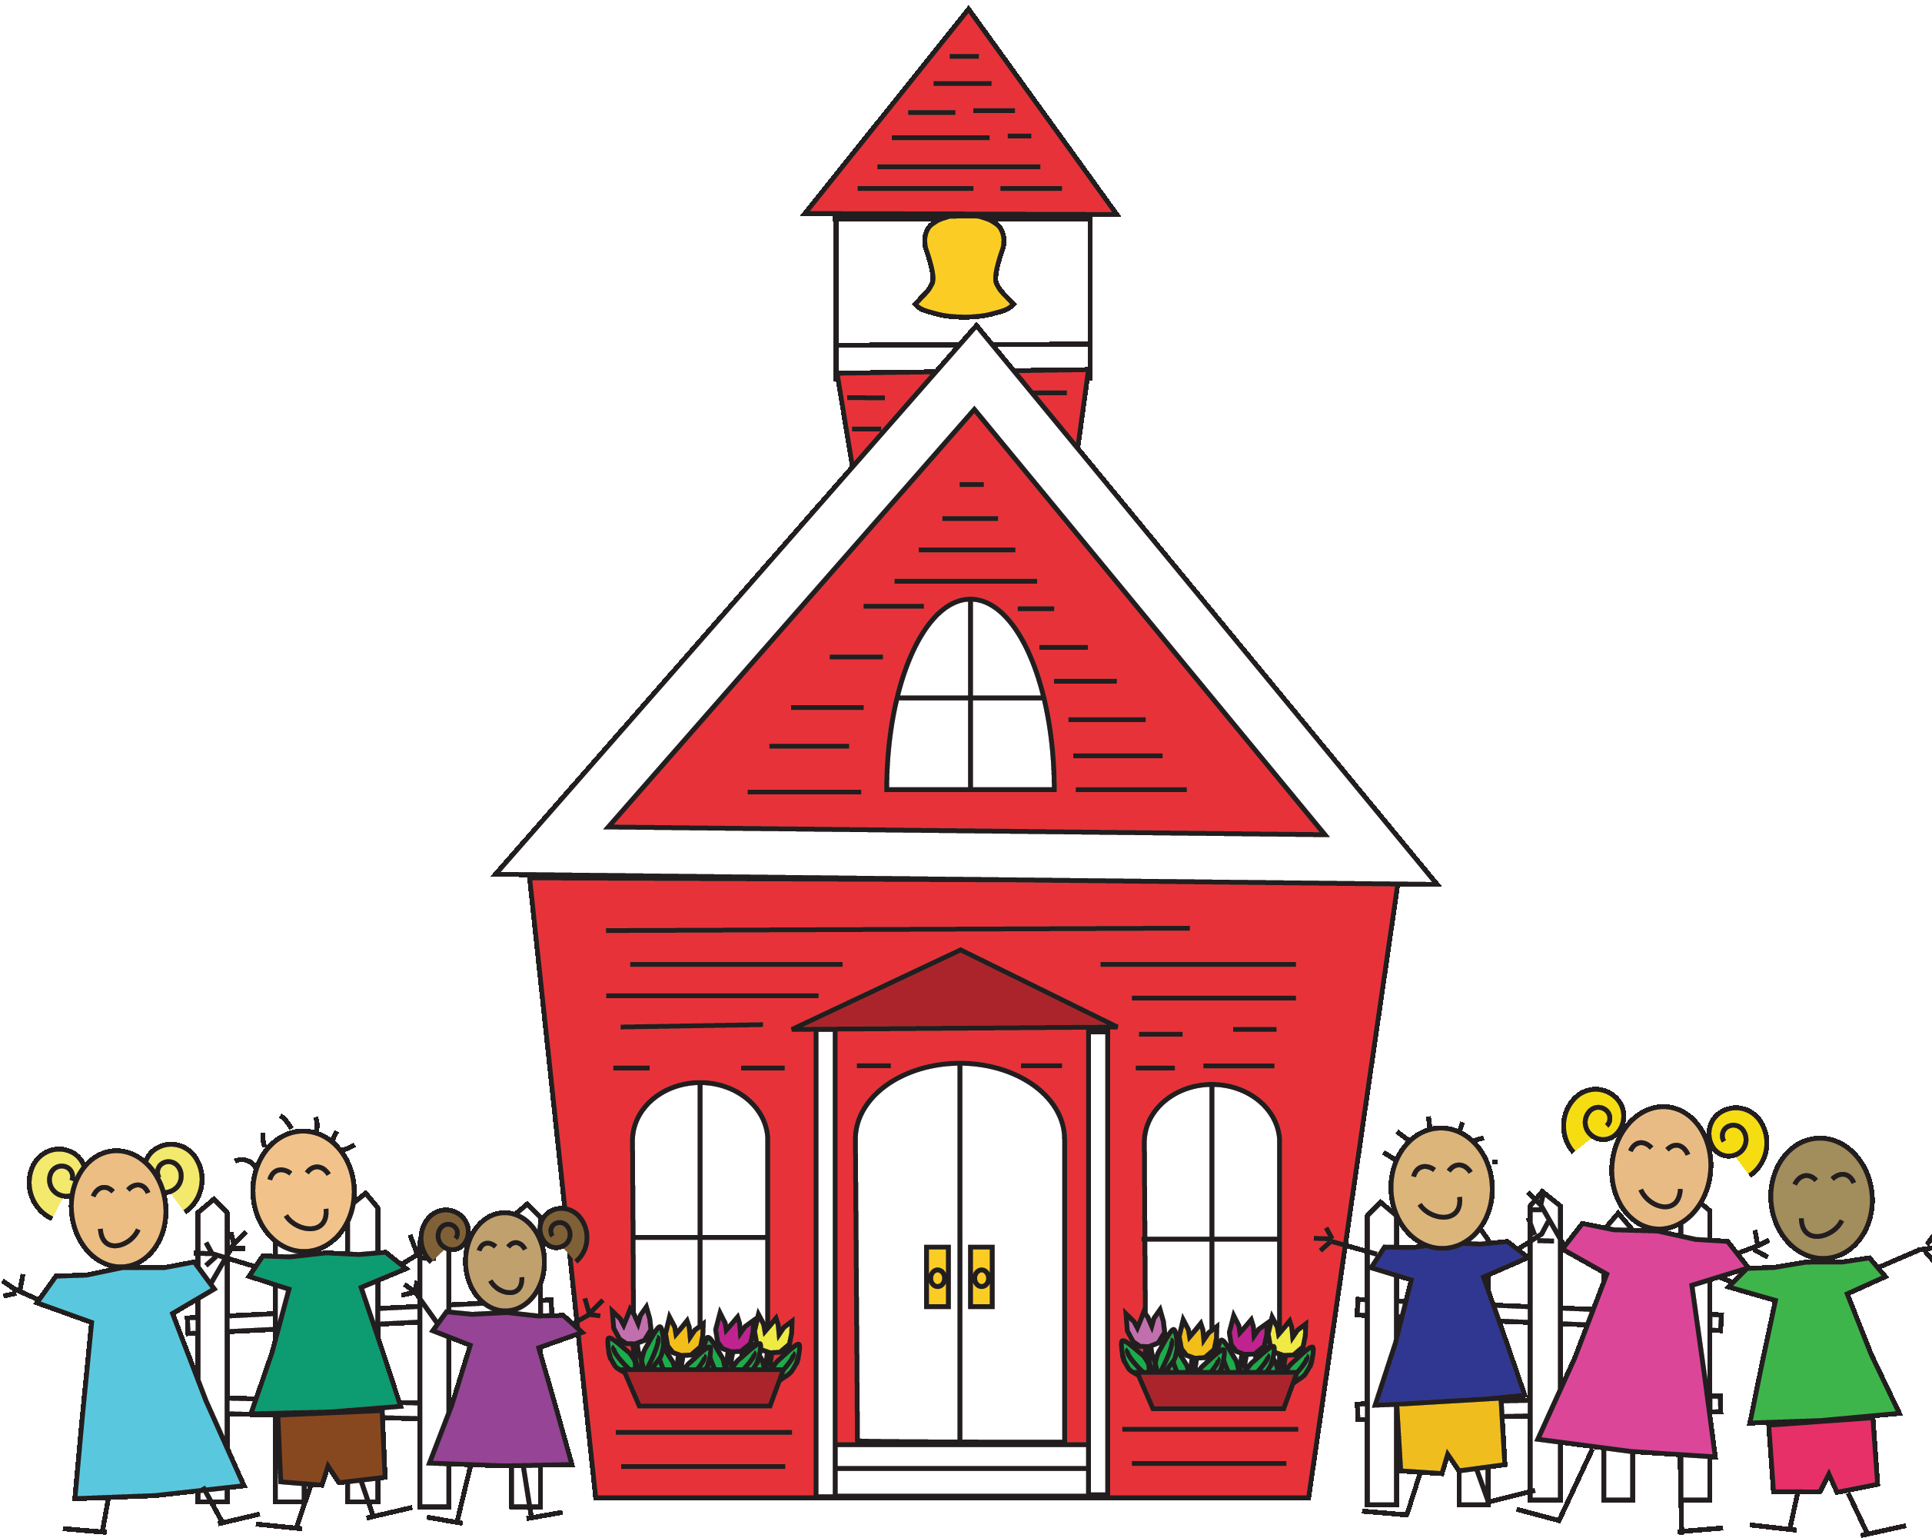
- Clingy
- Having sleep difficulties
- Reverting to early behaviours
(bedwetting, thumb sucking)
- Loss of appetite/Fussy eating

These are all ways in which your child is responding to a change in their routine, and new and challenging situations.

How To Deal With Common Reactions To Starting School

- Take time out to talk to your child about their anxieties and discuss what may help them to address and overcome these
- Work with school staff to address your child’s anxieties/worries
- Be there in simple ways for your child by supporting them with a cuddle, or partaking in their favourite activity
- Listen actively and be responsive to their needs
- Seek help and advice from school staff, general practitioner or school nurse if needed. You’re not on your own

Can Your Child….
Use a full sized knife & fork unaided
Use the toilet independently

Get dressed on their own
Wash their hands effectively



USEFUL RESOURCES: www.pacey.org.uk
www.nhs.uk
www.mumsnet.com



References: NHS Choices (Your Child’s First Day At School), Pacey.org.uk, Mumsnet.com, Childcare.co.uk, Kidsmatter.edu.au.

