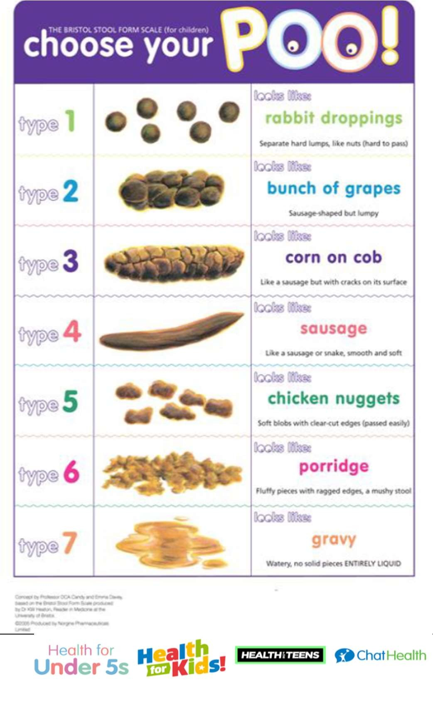
Healthy Together Continence Guidance V1
CHART 3

Please complete every day for the next 14 days
Baseline Assessment Chart for Nocturnal Enuresis – Week 1

Child’s Name: …………………………………………………… Date of Birth: ……………………………………………………….

 |  |  |  |  |  |  | 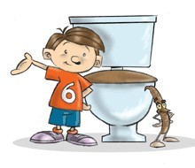
Date | What was | What | What | When | Did your | If wet, what | Has your child
 | the last | time did | time did | you | child | was the | had their
 | drink of | you go to | you go | checked | have a | size of the | bowels open
 | the day | bed? | & check | were | dry bed | wet patch | during the
 | in mls & |  | to see if | they | in the | - Small | day? Please
 | what |  | they | - Wet | morning | - Medium | describe using
 | time? |  | were  wet? | - Dry | - Yes  - No | - Large | the Bristol  Stool Chart

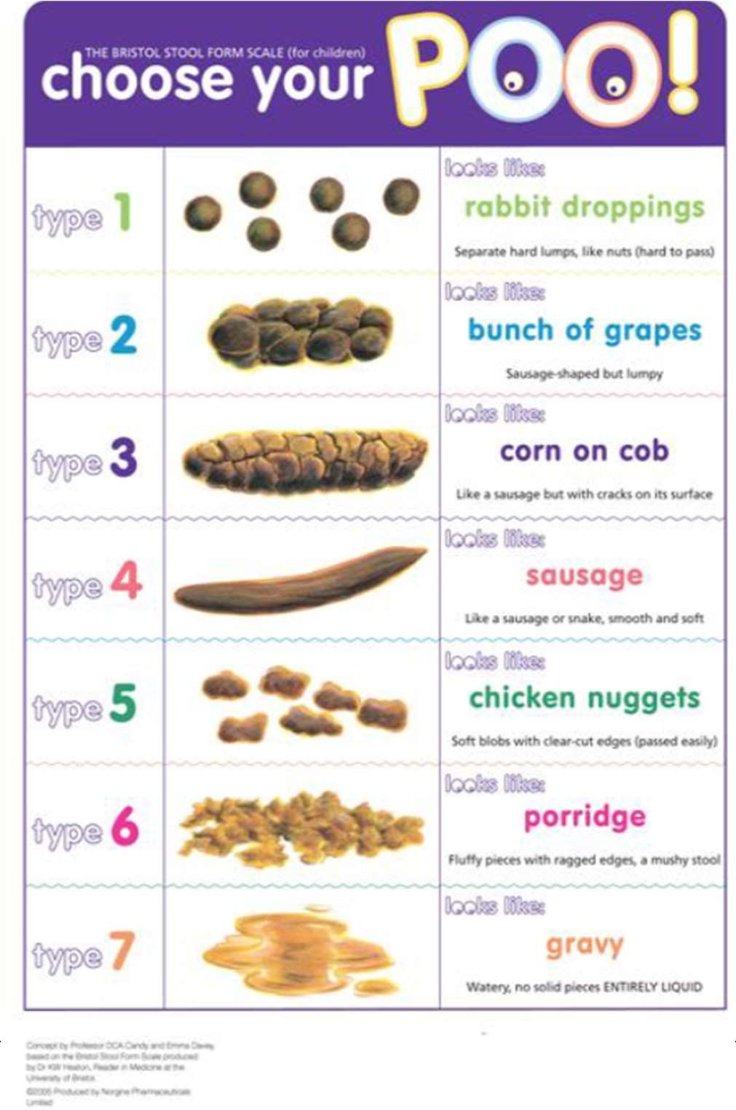
Healthy Together Continence Guidance V1
CHART 3a
Baseline Assessment Chart for Nocturnal Enuresis – Week 2
Child’s Name: …………………………………………………… Date of Birth: ……………………………………………………….

Date | What was | What | What | When | Did your | If wet, what | Has your child
 | the last | time did | time did | you | child | was the | had their
 | drink of | you go to | you go | checked | have a | size of the | bowels open
 | the day | bed? | & check | were | dry bed | wet patch | during the
 | in mls & |  | to see if | they | in the | - Small | day? Please
 |  |  |  | - Wet  - Dry | morning  - Yes  - No
 | what time? |  | they were wet? |  |  | - Medium  - Large | describe using the Bristol Stool Chart

