CHART 5
Bowel Record Chart

This chart is designed to give a good idea of your child’s bowel habits. Please fill in the chart every day (referring to the Bristol Stool Chart). Start the chart the day after you receive it.
Child’s Name: ……………………………………………….. Date of Birth: ……………
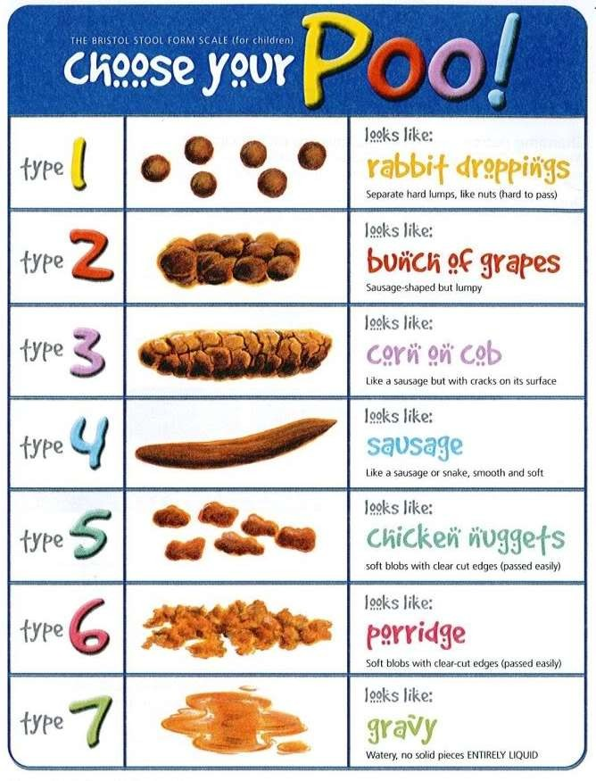
 |  | Type of stool | Quantity of stool  - Large  - Medium  - Small  - None | Pain and distress when passing stool  - Yes  - Some  - No | Where was the stool passed?  - Toilet  - Nappy  - Other | Pants soiled?
Date | Time | (use number from the Bristol Stool Chart) |  |  |  | Yes/No | Type of soiling  - Stained  - Loose  - Solid

24
Healthy Together Continence Guidance V1

