CHART 4
Chart for your drinks and wees
(Please complete for 4 days)
Child’s Name: …………………………………… Date of Birth: …………………………………….

Day 1 |  | Date: |  | Day 2 |  | Date:
Time  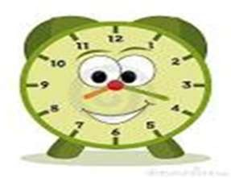 | Size of drink in mls | Time  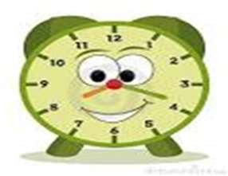 | Size of wee in mls  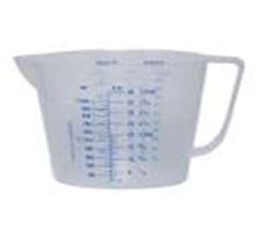 | Time  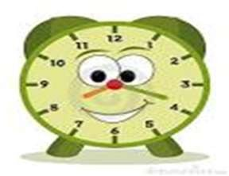 | Size of drink in mls | Time  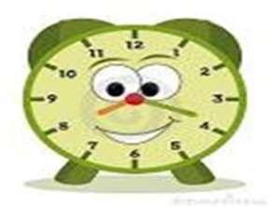 | Size of wee in mls  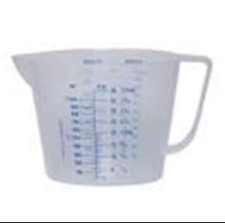

21
Healthy Together Continence Guidance V1

Chart for your drinks and wees
(Please complete for 4 days)

Child’s Name: …………………………………… Date of Birth: …………………………………….
CHART 4a

Day 3 |  | Date: |  | Day 4 |  | Date:
Time  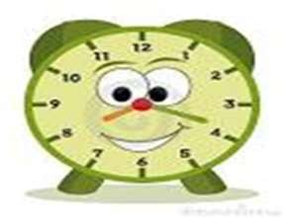 | Size of drink in mls | Time  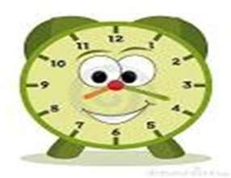 | Size of wee in mls  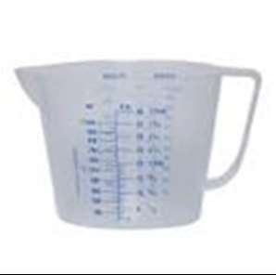 | Time  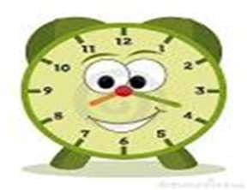 | Size of drink in mls | Time  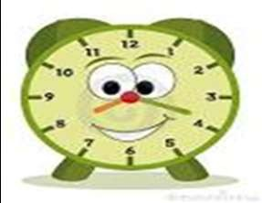 | Size of wee in mls
22

Healthy Together Continence Guidance V1

TOP TIPS FOR COMPLETING 4 DAY CHART

To help with your child’s assessment, we need a record of everything your child drinks and wees for 4 days. This must be 4 complete days whether separate or all together it does not matter. Most people choose to do over two weekends, as this information is difficult to obtain whilst at school.
DRINKS
- Give drinks in the same cup. Measure the amount of fluid this cup will hold - you then only need to measure the cup in millimetres (mls) once.
- Write down the time the drink was consumed.
- Write down the amount in mls that was consumed.
- Write down the type of drink your child has consumed.

WEES 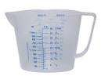 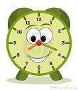
- Use an old or cheap plastic measuring jug.
- Your child needs to wee in the jug rather than the toilet so the amount of wee can be measured. Write down the amount on the chart in mls.
- Please write down the time of each wee.

PLEASE REMEMBER TO FILL IN YOUR CHILD’S NAME AND DATE OF BIRTH ON THE CHARTS

23
Healthy Together Continence Guidance V1

