Toileting Chart for Children and Young People with Additional Needs

To help plan a toileting programme and help identify any underlying problems, please complete the toileting chart.
Modern disposable nappies/products have what is called ‘super absorbency’ inside them. This ‘locks’ away urine, so the top layer stays dry next to your child’s skin. However, it also means that it can be difficult for you to know how many times a day your child passes urine. We suggest that you put something in the nappy/product, so that when you can check it you can easily feel if they have passed urine (wee). This could be a folded piece of kitchen roll (one that does not disintegrate when wet).
Pick times when you are going to be home for most of the time. At the first nappy/product change of the day, put the kitchen roll liner inside the nappy/product. Check the nappy/product every hour and record on the chart whether the pad was Wet (W) or DRY (D). If the kitchen roll is wet change it, but the nappy/product can stay on until it cannot hold any more urine – in other words change the nappy/product when you normally would.
If your child has opened their BOWELS please describe using the Bristol Stool Chart number. If your child uses the toilet at any time, indicate what happened in the toileting column.
Each time your child has a drink, record it by putting how much they have drunk (please put in mls) in the drinks column.
Try and carry on charting for as many days as you can, but for at least 4 days. Please remember to bring this chart with you to your appointment.
Thank you

26
Healthy Together Continence Guidance V1

Remember to check the nappy every hour and record on the chart.
CHART 6
Wet (W) or DRY (D), or BOWELS OPEN (Use the Bristol Stool Chart number).
 | Day 1 |  |  |  | Day 2
DATE |  |  | mls | Number |  |  | mls | Number
TIME | Toilet | Nappy/  Product | Drink | Bowels | Toilet | Nappy/  Product | Drink | Bowels
7.00
8.00
9.00
10.00
11.00
12.00
13.00
14.00
15.00
16.00
17.00
18.00
19.00
20.00
21.00
Any night changes:
 | Day 3 |  |  |  | Day 4
DATE |  |  | mls | Number |  |  | mls | Number
TIME | Toilet | Nappy/  Product | Drink | Bowels | Toilet | Nappy/  Product | Drink | Bowels
7.00
8.00
9.00
10.00
11.00
12.00
13.00
14.00
15.00
16.00
17.00
18.00
19.00
20.00
21.00
Any night changes:

CHART 6a

Remember to check the nappy every hour and record on the chart.
Wet (W) or DRY (D), or BOWELS OPEN (Use the Bristol Stool Chart number).
 | Day 5 |  |  |  | Day 6
DATE |  |  | mls | Number |  |  | mls | Number
TIME | Toilet | Nappy/  Product | Drink | Bowels | Toilet | Nappy/  Product | Drink | Bowels
7.00
8.00
9.00
10.00
11.00
12.00
13.00
14.00
15.00
16.00
1700
18.00
19.00
20.00
21.00
Any night changes:
 | Day 7 |  |  |  | 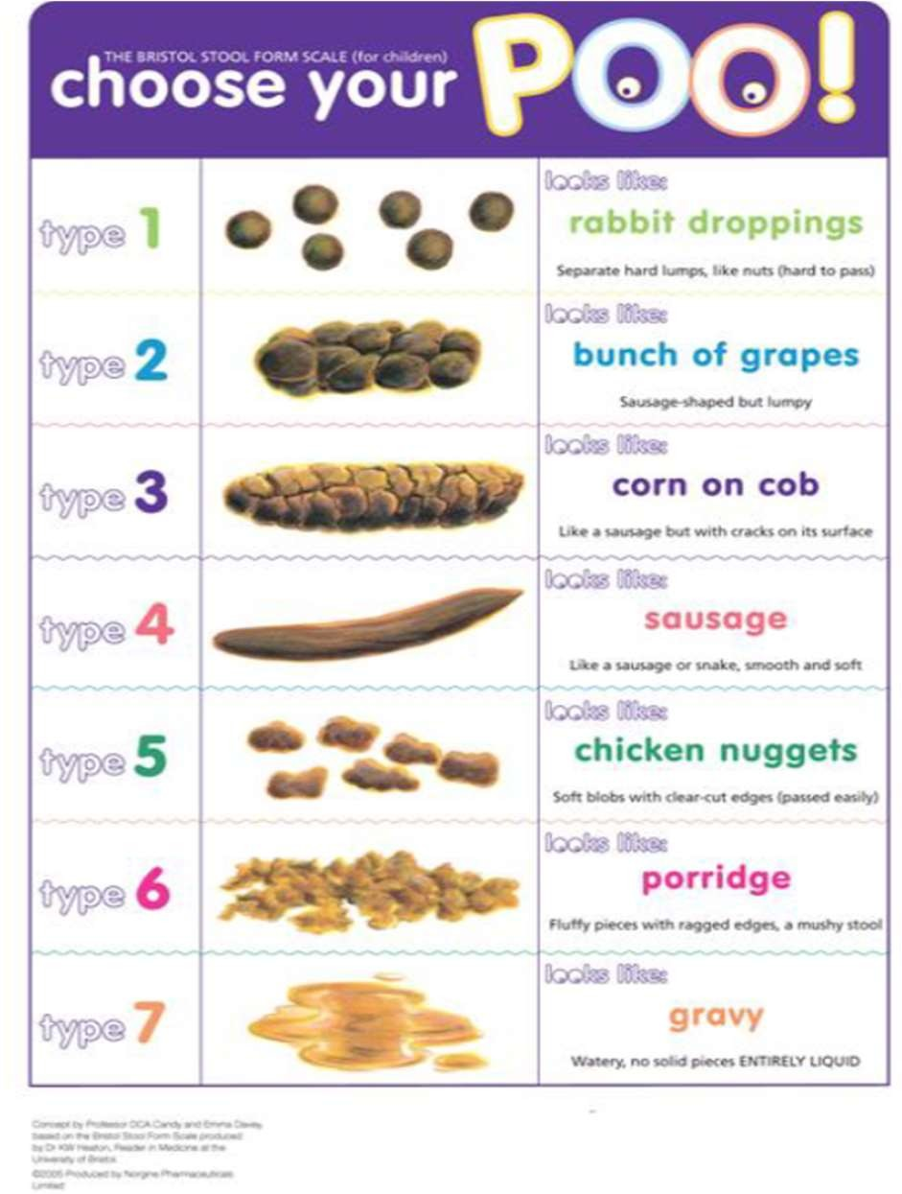
DATE |  |  | mls | Number
TIME | Toilet | Nappy/  Product | Drink | Bowels
7.00
8.00
9.00
10.00
11.00
12.00
13.00
14.00
15.00
16.00
17.00
18.00
19.00
20.00
21.00
Any night changes:

CHART 7
Wee Time Chart
Child’s Name: …………………………………………………………. Date of Birth: ………………………Date chart started:……………………..

MONDAY |  |  |  |  | TUESDAY
Time to go | Were you | Were you | Did you | Was it | Time to go | Were you | Were you | Did you | Was it
to the toilet | dry or wet? | sent or did | wee in the | urgent? | to the toilet | dry or wet? | sent or did | wee in the | urgent?
 |  | you go by | toilet? |  |  |  | you go by | toilet?
 |  | yourself? |  |  |  |  | yourself?

Wee Time Chart

Child’s Name: Date of Birth:
…………………………………………………………...

WEDNESDAY |  |  |  |  | THURSDAY
Time to go | Were you | Were you | Did you | Was it | Time to go | Were you | Were you | Did you | Was it
to the toilet | dry or wet? | sent or did | wee in the | urgent? | to the toilet | dry or wet? | sent or did | wee in the | urgent?
 |  | you go by | toilet? |  |  |  | you go by | toilet?
 |  | yourself? |  |  |  |  | yourself?

Wee Time Chart

Child’s Name: Date of Birth
…………………………………………………………...

FRIDAY |  |  |  |  | SATURDAY
Time to go | Were you | Were you | Did you | Was it | Time to go | Were you | Were you | Did you | Was it
to the toilet | dry or wet? | sent or did | wee in the | urgent? | to the toilet | dry or wet? | sent or did | wee in the | urgent?
 |  | you go by | toilet? |  |  |  | you go by | toilet?
 |  | yourself? |  |  |  |  | yourself?

Wee Time Chart

Child’s Name: …………………………………………………………. Date of Birth: ……………………………………………...
CHART 7c
SUNDAY
Time to go to the toilet | Were you dry or wet? | Were you sent or did you go by yourself? | Did you wee in the toilet? | Was it urgent?

