[](http://www.google.co.uk/url?url=http://broadcast.oreilly.com/2009/02/free.html&rct=j&frm=1&q=&esrc=s&sa=U&ei=ilgJVcq6HYLOPej2gIgG&ved=0CDIQ9QEwDjgU&usg=AFQjCNEVjNB1d7-nhKFMTvRj00cJO8yhuw)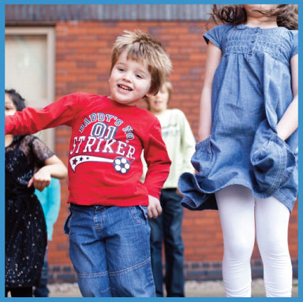

**Anger Management Group**

Groups for Children and Young People

To help them understand their anger so that they can make healthy and successful choices.

Anger is a normal emotion and is in itself not a problem; the problem with anger comes when people have not learned to manage the associated physical and emotional responses effectively. Children are no different to adults in that we all get annoyed at times; if children are not expected to express their anger, they will bottle it up, often leading to an explosive outburst or tantrum.

Each course runs for **6 weeks** and each session lasts for 1 hour. The groups will be run by staff from the School Nursing service who are trained to deliver these programs.

Sessions are designed to be fun and enjoyable for children and young people. The will learn new skills through talking, playing games and taking part in other fun activities.

Sessions include:

* How to understand their feelings
* Body clues
* The link between thoughts, feelings and behaviours
* How to recognise angry feelings in the early stages
* How to express angry feelings in a safe and appropriate way
* To learn alternatives to physical and verbal violence to express anger
* Learn how relaxation can help

**If you are a parent or carer and you would like further information or to book your child a place on the above course then please contact us by email or phone:**

**Email:** [**wellbeing@walsallhealthcare.nhs.uk**](mailto:wellbeing@walsallhealthcare.nhs.uk)

**Phone: Tel: 01922 423349**