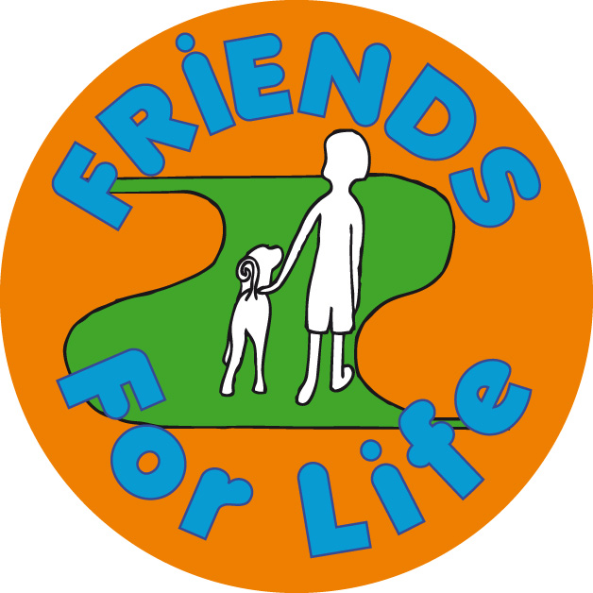

[](http://www.google.co.uk/url?url=http://broadcast.oreilly.com/2009/02/free.html&rct=j&frm=1&q=&esrc=s&sa=U&ei=ilgJVcq6HYLOPej2gIgG&ved=0CDIQ9QEwDjgU&usg=AFQjCNEVjNB1d7-nhKFMTvRj00cJO8yhuw)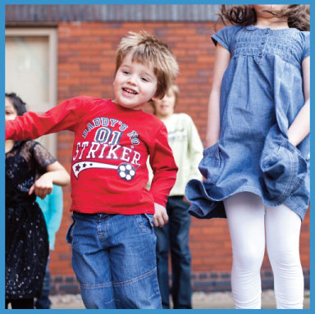

Friends for Life groups are for children aged between 7 & 11 years (primary school) and Teenagers (secondary school). These programs teach children and young people skills that help promote self esteem and improve confidence.

Each course runs for **8 weeks** and each session lasts for 1 hour. The groups will be run by staff from the School Nursing service who are trained to deliver these programs.

Sessions are designed to be fun and enjoyable for children and young people. The will learn new skills through talking, playing games and taking part in other fun activities. Each child or young person will receive their own FRIENDS book to keep.

Sessions include:

* Understanding emotions in yourself and others
* How to make and maintain friendships
* Dealing with bullying & peer pressure (primary Program,) Managing Conflict (Teen Program)
* Problem solving, positive coping strategies, relaxation skills
* Changing unhelpful thinking into more helpful thinking

If you are a parent or carer and you would like further information or to book your child/teen a place on one of the above course then please contact us by email or phone:

**Email:** [**wellbeing@walsallhealthcare.nhs.uk**](mailto:wellbeing@walsallhealthcare.nhs.uk)

**Phone: Tel: 01922 423349**

**FRIENDS for Life**

Groups for Children and Young People

To help Improve Self Esteem and Confidence